
Running a Live Event on Microsoft Teams

What are Teams Live Events?
Teams Live Events is an extension of Teams meetings, enabling you to produce events for large online audiences with more control over video, audience interaction, and reporting. The Council have used them to run online consultations, strategy meetings with the public, Area Committee and monthly Council meetings and more.

9 Quick Steps to Setting Up Your Meeting
- To create a live event in Teams, select Meetings on the left side of the app and then New meeting.
- At the top of the dialogue box, select New meeting > New live event.
- Add the meeting title, date and time information, and other details.
- In the Invite people to your event group box, add the names of the people who will be presenting and producing the event.
- Select Next.
- Under Live event permissions, choose who can attend your live event.
- Make selections under How do you plan to produce your event?
- Select Schedule.
- Select the Get attendee link to copy the unique code. This is what you post or send to anyone attending the event.

5 Steps to Running a Quality Live Event

Step 1: Plan the live event

Just like an in-person gathering, a live event works best when properly planned ahead of time. To ensure a good experience for your attendees, you should assign roles to staff members when considering the event. Some roles to consider are:
- Organiser - schedules the live event and ensures the event is set up with the right permissions for attendees and the event group, who will manage the event.
- Producer – manages the live event, making sure attendees have a great viewing experience by controlling the live event stream. Responsible for starting and stopping the live event and switching between presenters. Having a person dedicated to the producer role makes sure that presenters are not burdened with managing the event and allows presenters to leave the event after they have finished presenting.
- Presenter - shares audio, video, or a screen to the live event.
- Moderator (if needed) –joins the event in the “presenter” role to moderate and monitor questions and answers. Having a designated moderator ensures timely attention to the questions asked by the attendees and makes for a better attendee experience.

Step 2: Schedule a live event from Microsoft Teams

After you have planned the event and assigned roles, you are ready to schedule your event! You can schedule a live event just like any other meeting, using the calendar in Microsoft Teams. First, you will enter event information, including the title, date, and time, and assign people to roles.

Depending on the audience for your event, you can create a Private or a Public event. Public events are a great option to consider for events such as online consultations. If an event is public, anyone who has the link can attend without logging in.
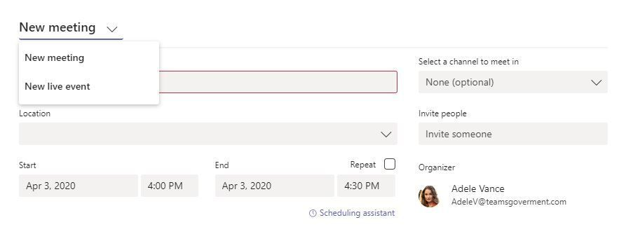

Next, you will select a People and Groups, Council-wide or a Public event. If an event is public, anyone who has the link can attend without logging in. If it is an online consultation then you must ensure that it is set to a Public Event so members of the public can view and/or take part.
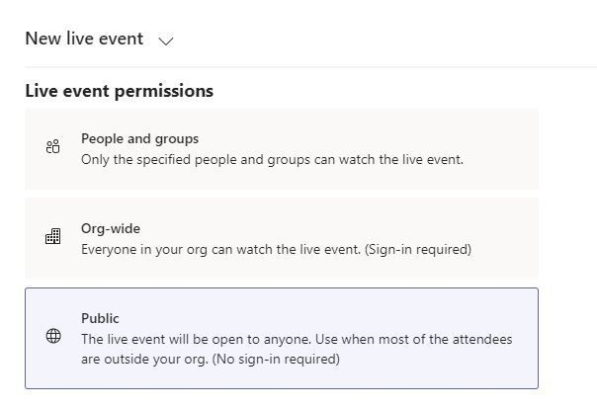

Step 3: Invite attendees to the meeting

As a live event organiser, one of your responsibilities is to invite attendees. When you schedule a live event in Teams, it automatically sends the calendar invite to producers and presenters. From the calendar entry in Teams, you can get a link to the event and send it out to attendees. If you want to promote your event to the public, make sure to contact the Communications Unit ahead of time to advertise on social media. Remember to inform elected members of the event and send them the link with event details as well.
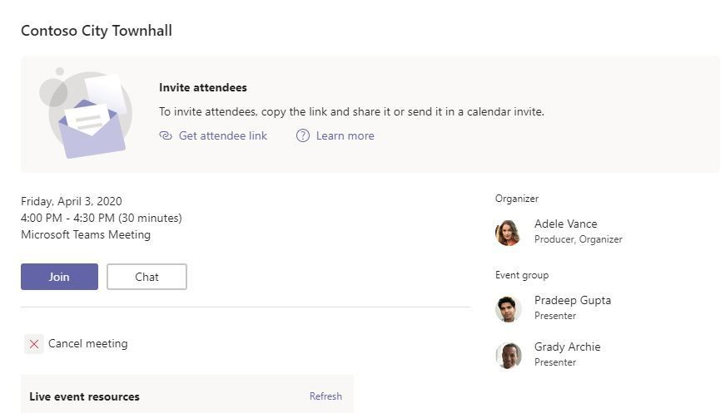

Step 4: Go live

When you want to start the live event, select “Join” from the invite. You will enter the event in setup mode. In this mode, you can add content and video you want to go live with. It is a good idea to run a test event in advance just to make yourself familiar with these options.

Step 5: Manage recording and reports

After the live event is over, you can choose to download the recording, as well as attendee and Question and Answer (Q&A) reports. If it is a public-facing event, download these for your records and to reference in case of any follow-up queries. Any recordings made, however, must comply with data protection regulations and the recording purpose and retention period must be stated.

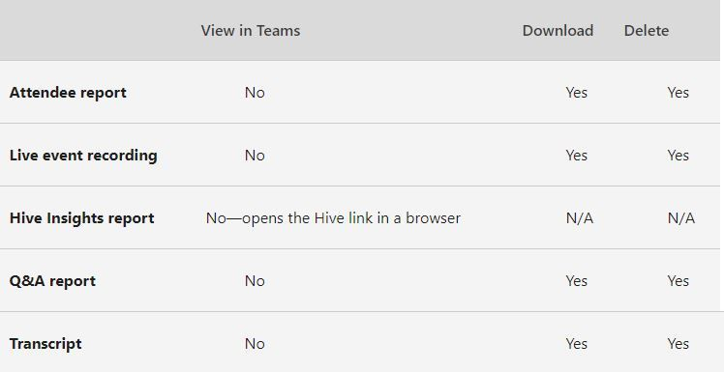

You can get more detailed information on running a Teams Live Event in this instructional guide.

Useful Tips in Preparing for the Meeting

Testing software

As a speaker, it is important to ensure that you can access the meeting. A checklist of questions you may wish to run through beforehand could be:
- Are you clear on how to access the meeting?
- Has your laptop / other hardware got a camera?
- Does your microphone work?
- Does your headset work?
- Do your speakers work?
- Is your laptop plugged in or fully charged and working appropriately?
You should trial MS Teams beforehand so you are comfortable with the use of the software.
Identity presentation

Ensure that you position yourself in the viewing frame so that Members/viewers can see your shoulders and face.

Treatment of other household electronic devices

Where possible, it is advisable to remove other electronic devices from the room in which you are located or to switch them off. There is a potential for interference and/or feedback during live streaming arising from electronic equipment. Of particular note is the potential for slow connectivity when large amounts of the bandwidth are taken by other device users in the household (if at home).
Telephones

Ensure that all phones, landline and/or mobiles are switched to silent throughout your participation in the meeting so that you can be heard clearly.

Surroundings

Have a look at where you are planning to access the meeting. The environment should be quiet with no interruptions. You may consider how you can prevent interruptions from others in the household. A sign on the door is useful and/or verbal notification of the event.

Lighting

Can you be seen clearly? If you sit next to a light, is there a brightness that glares in your face obscuring the viewing frame? Viewers will want to be able to see who you are. Is there glare from a window behind you?

Access Considerations for Live Events

Concerning live streaming, several access considerations must be addressed for the message/speech to be accessible for deaf people and those who are hard of hearing. These include:

- The camera should not be so far away that it makes the speaker look small onscreen which makes lip-reading impossible,
- Standing beside or in front of a window affects light quality and makes it difficult for people who lip read to see the speakers face,
- Adequate lighting must be provided to facilitate lip-reading,
- Closed captions should be provided. It is possible to have real-time captioning for live streaming,
- If due to time constraints closed captioning cannot be provided, a full-text transcript should be made available online,
- Where possible Irish Sign Language interpretation should be provided.

The same considerations apply to pre-recorded/commissioned videos.

It is important to remember that we have legal responsibilities under both the Disability Act 2005 and the Irish Sign Language Act 2017.

Council branding for Live Events

When making presentations to staff, the public and other key stakeholders; it is important to make a good impression and convey the right message about the Council. Microsoft Teams is a format that relies heavily on good quality visuals to keep an audience engaged and so your presentation needs to meet that challenge. The importance of presentation design in is critical when highlighting upcoming initiatives of the Council’s as you don’t want to sell the work you are doing short through misuse of images, fonts or by overloading your slides with text.

We have designed three templates PowerPoints that are available for you to use. From very basic to more advanced. You are free to use and edit them by clicking on each below:

- Simple PowerPoint 1
- Simple PowerPoint 2
- Advanced PowerPoint

If editing then please refer to the Council’s branding guidelines for fonts, colours, logo use etc.

